**SOLUTION ARCHITECTURE**

TITLE: INDUSTRY SPECIFIC INTELLIGENT FIRE MANAGENTSYSTEM

Team ID: PNT2022TMID18163

Arduino triggers the relay module

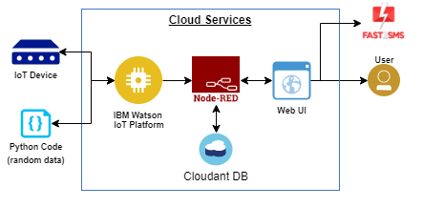

NOTIFICATION ALERT

**REPORTS**